
CYB 105-T01 Cybersecuirty Foundations
MODULE 2: CHAPTER 2: EXERCISE 2.1-2.5

September 5, 2025

Professor: Karry Elson
Student: Jamison Durham

Table of Contents
Chapter 2: Windows Commands Exercise 2.1-2.5 2
Netstat 2.3 Project……………………………………………………………………………………………………………………………….10
Wireshark Packet Capture……………………………………………………………………………………………………………………13
References……………………………………………………………………………………………………………………………………………16

Chapter 2: Windows Commands Exercise 2.1-2.5

QUESTION:
EXERCISE 2.1: Using IPConfig
Open your command prompt or type cmd in the search bar in Windows 10 or 11.
Type in ipconfig.
Use the output of the IPConfig command to find out information about your computer.
Write down your computer’s IP address, default gateway, and subnet mask.

ANSWER:
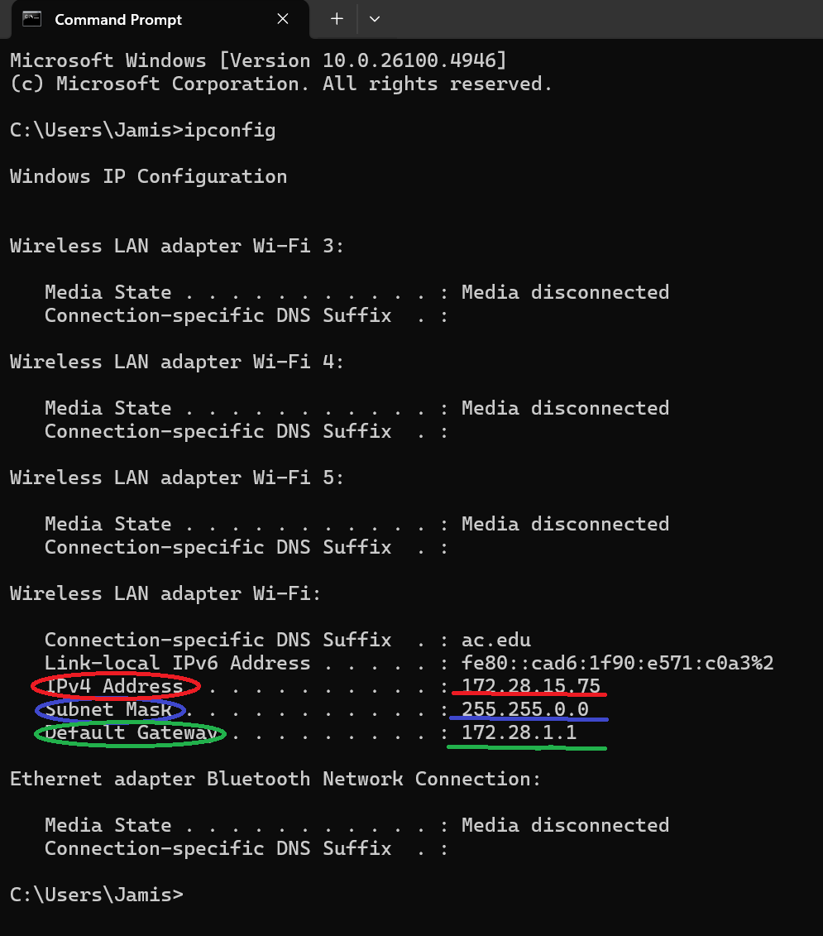
The highlighted correlates with the different addresses (IP, Mask, Default Gateway).
- Windows Laptop IP Address: 172.28.15.75
- Default Gateway: 172.28.1.1
- Subnet Mask: 255.255.0.0

QUESTION:
EXERCISE 2.2: Using Tracert
Open your command prompt or type cmd in the search bar in Windows 10.
Type in tracert www.chuckeasttom.com.
Note what hops your computer takes to get to www.chuckeasttom.com.
Repeat steps 2 and 3 with www.whitehouse.gov and http://home.pearsonhighered.com/.
Notice that the first few hops are the same. Write down what hops are taken to reach each destination and what hops are the same. Then briefly describe why you think some of the intermediate steps are the same for different destinations.

ANSWER:
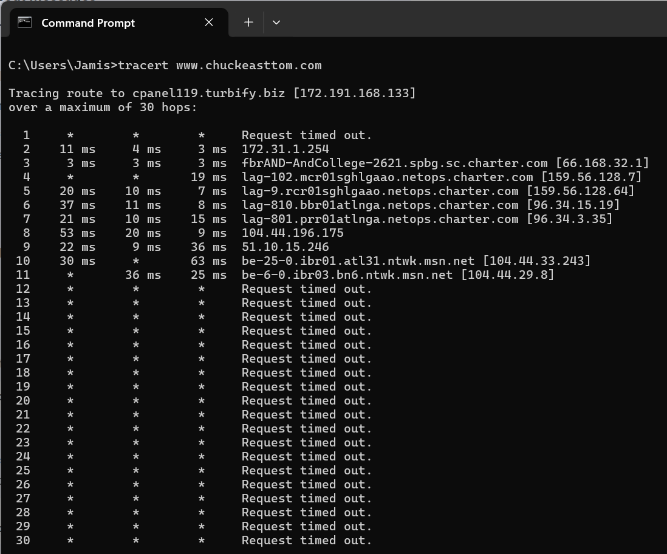
Tracert given the website www.chuckeasttom.com
This trace route has a maximum of 30 hops although only 11 hops are recorded in this trace.
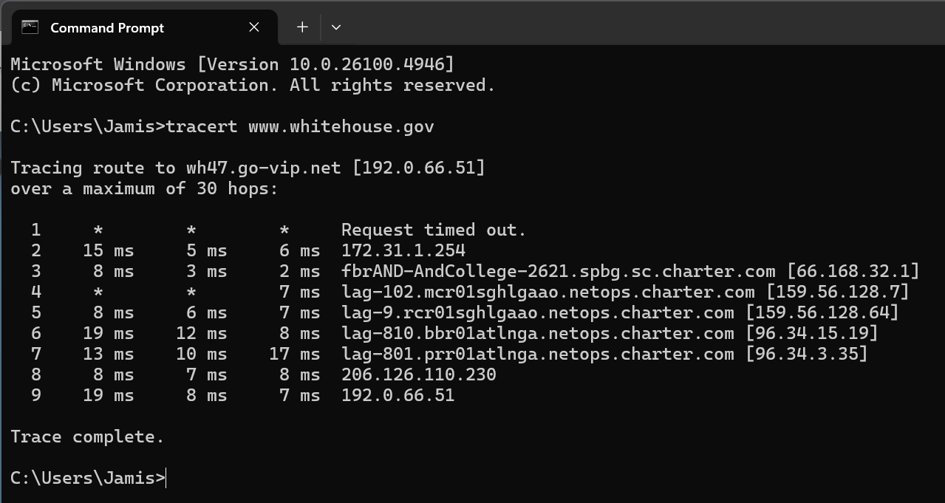
Tracert given the website www.whitehouse.gov
www.whitehouse.gov only takes 9 hops to retrieve access through the routers.

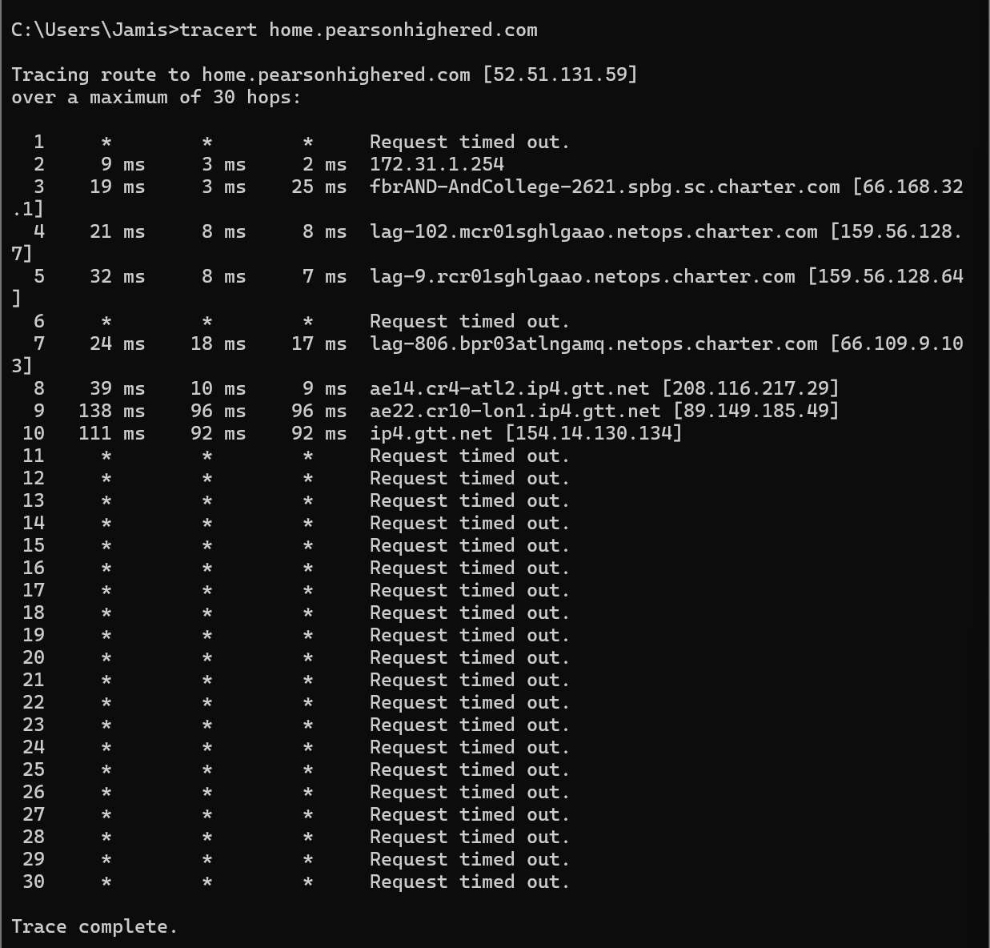
Tracert given the website http://home.pearsonhighered.com/.
30 maximum hops with hops only being recorded until 10.
Continued…
www.chuckeasttom.com (5 hops)
- 172.191.168.133
- 172.31.1.254
- 66.168.32.1
- 159.56.128.7
- 159.56.128.64
www.whitehouse.gov (5 hops)
- 192.0.66.51
- 172.31.1.254
- 66.168.32.1
- 159.56.128.7
- 159.56.128.64
http://home.pearsonhighered.com/. (4 hops)
- 52.51.131.59
- 172.31.1.254
- 66.168.32.1
- 159.56.128.7

Starting at the first hop (not the first bullet point, starting at the second), all the hops are the same for 3 hops, and the same 4 hops are the same for www.chuckeasttom.com and www.whitehouse.gov. This shows the packet of data leaving through the local routers until they take different paths to different servers and ISP centers.

QUESTION:
EXERCISE 2.3: NSLOOKUP
Go to the command prompt or type cmd in the search bar in Windows 10.
Type nslookup www.chuckeasttom.com.
Note that this command gives you the actual name of the server, as per the hosting company’s naming conventions; its IP address; and any aliases under which that server operates.

ANSWER:

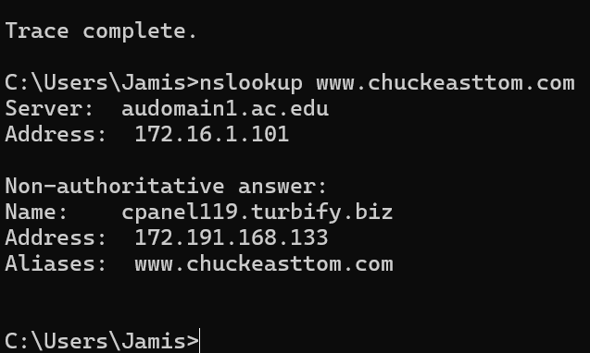
IP Address: 172.16.1.101
Server: audomain1.ac.edu
Aliases IP: 172.191.168.133

QUESTION:
EXERCISE 2.4: More About IPConfig
Open your command prompt or type cmd in the search bar in Windows 10.
Use the -? flag with the IPConfig command to find out what other options you have with IPConfig. You should notice a number of options, including /all, /renew, and others.
Now try ipconfig /all. What do you see now that you didn’t see when you simply used ipconfig in Exercise 2.1?

ANSWER:
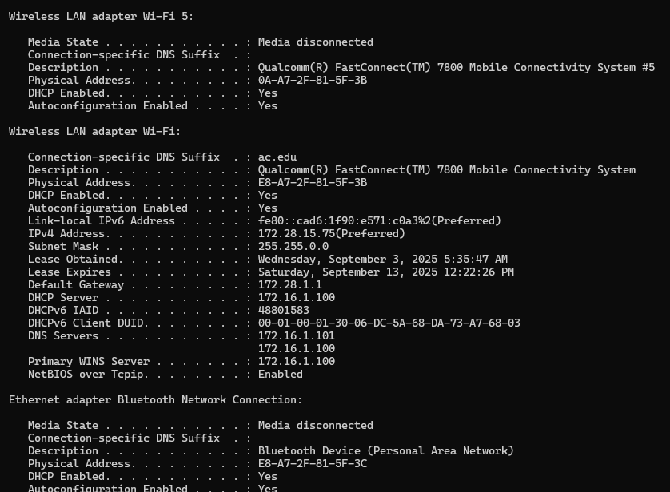
You receive all the information in the ipconfig command with more additional information regarding the DNS servers, and the DHCP servers as seen in the Wireless LAN adapter Wi-Fi.
As well as the HOST name and the MAC address.

QUESTION:
EXERCISE 2.5: More About Ping
Open your command prompt or type cmd in the search bar in Windows 10.
Use the -? flag on the ping command and find out what other options you have with ping. You should notice several additional options, such as -w, -t, -n, and -i.
Try ping www.chuckeasttom.com.
Try the option ping -n 2 www.chuckeasttom.com. Then try ping -n 7 www.chuckeasttom.com. What differences do you notice?

ANSWER:
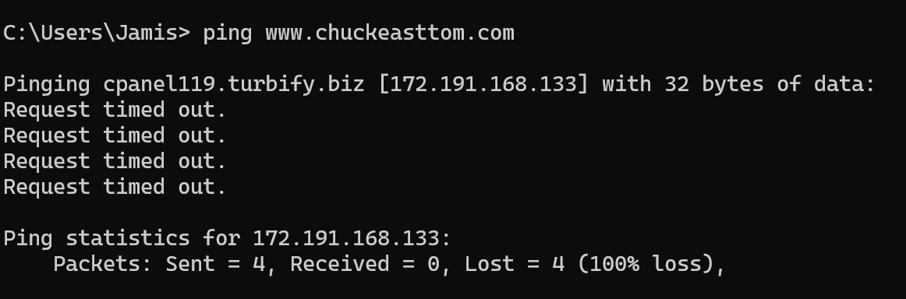
Regular ping www.chuckeasttom.com.

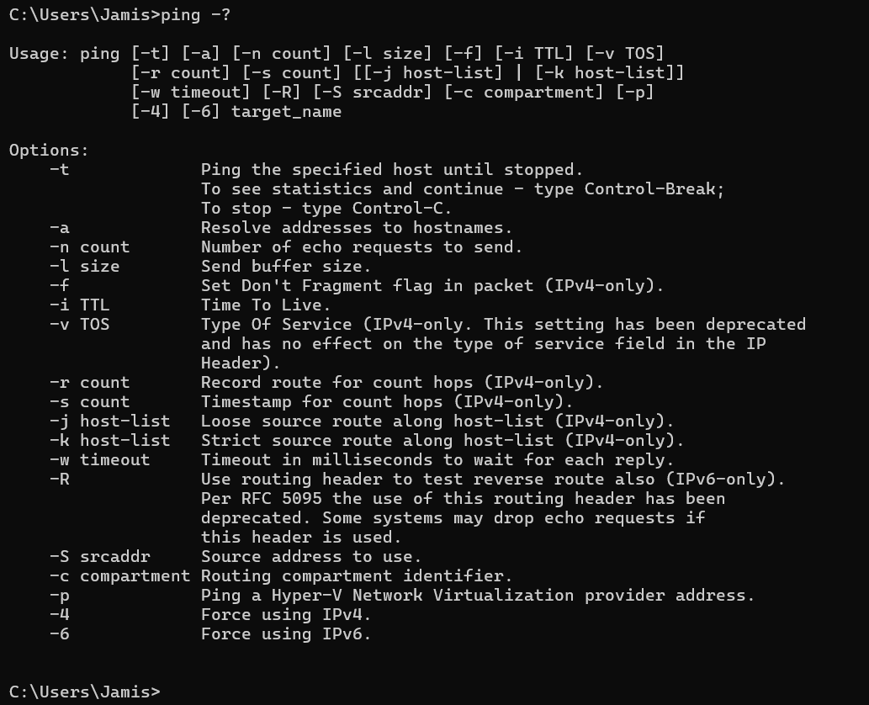
Ping -? Flag with options.

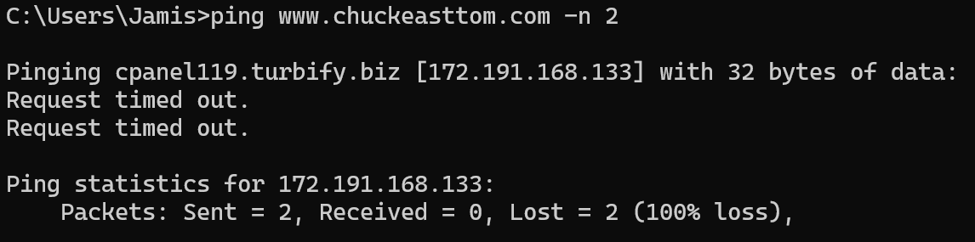
Ping www.chuckeasttom.com -n 2
The first one automatically sends out 4 echoes although with the -n 2 flag, it reduces the number of echoes sent out and received.

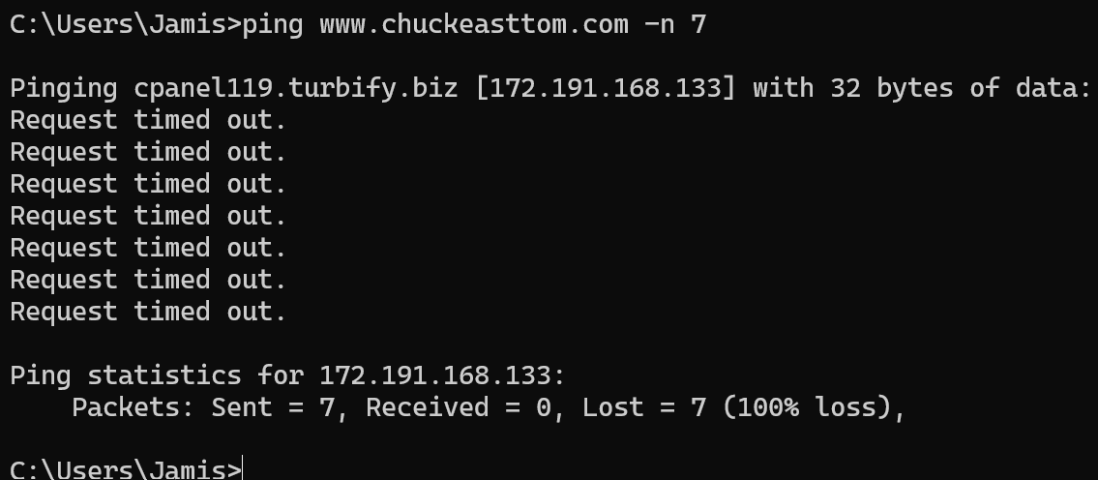
Ping www.chuckeasttom.com -n 7
Instead of reducing the number of echoes that were sent and received, it added three more to the four that were originally sent out under the command ping www.chuckeasttom.com with no flags.

Netsat 2.3 Project

QUESTION:
PROJECT 2.3: Learning About NetStat
- At the command prompt, type netstat. Notice the information it provides you with. You should see the IP addresses or names of servers that are currently connected to your computer. If you are using a home computer, you will need to log on to your Internet service provider to see anything.
- Now type in netstat -? to see what options are available for this command. You should see -a, -e, and others.
- Now type in netstat -a and note the information you see.
- Finally, try netstat -e. What do you see now?

ANSWER:

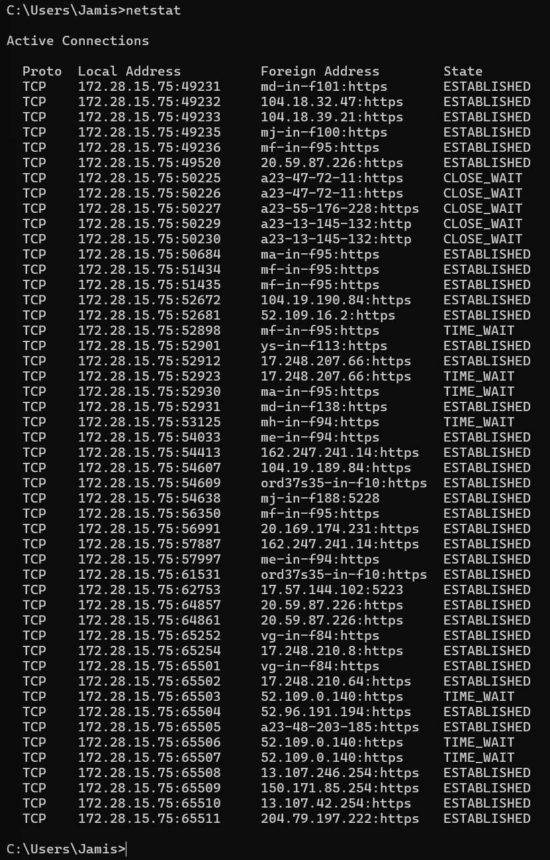
Command: Netstat

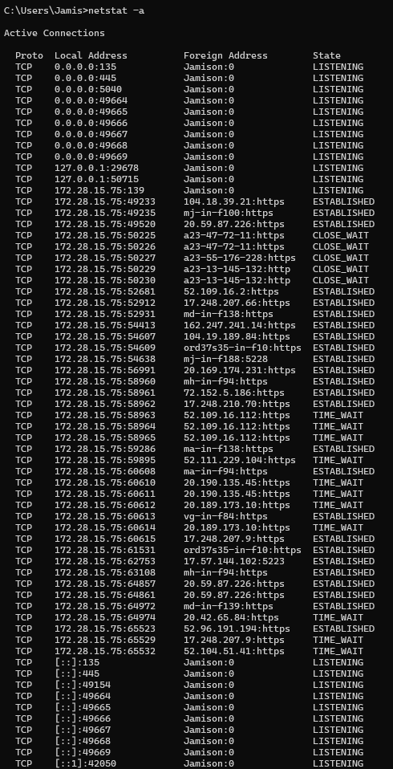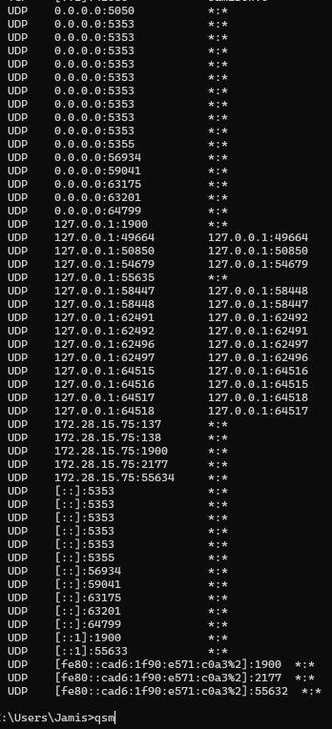
Netstat -a shows more than just the command netstat, as it includes the connections and the listening ports as well.

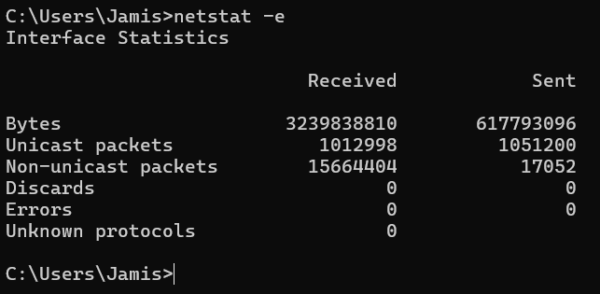
Netstat -e shows the ethernet interface, or the network traffic through ethernet.

Wireshark PAcket Capture

ASSIGNMENT:
Chapter 2. Wireshark Packet Capture
Install Wireshark on your own laptop or desktop. Capture a bunch of packets. Provide three screenshots showing different aspects of your capture. Answer the following questions. You may use a highlighting tool or use captions to point out the following in your capture:
1) Show one private and one public IP address.
2) Show a TCP and a UDP packet. What is a TCP and UDP packet?
3) Show a TLS packet. What is a TLS packet?
4) How many total packets in your capture?
5) Do a ping of 1.1.1.1. Show this activity in Wireshark. What protocol does ping use?

RESPONSE:
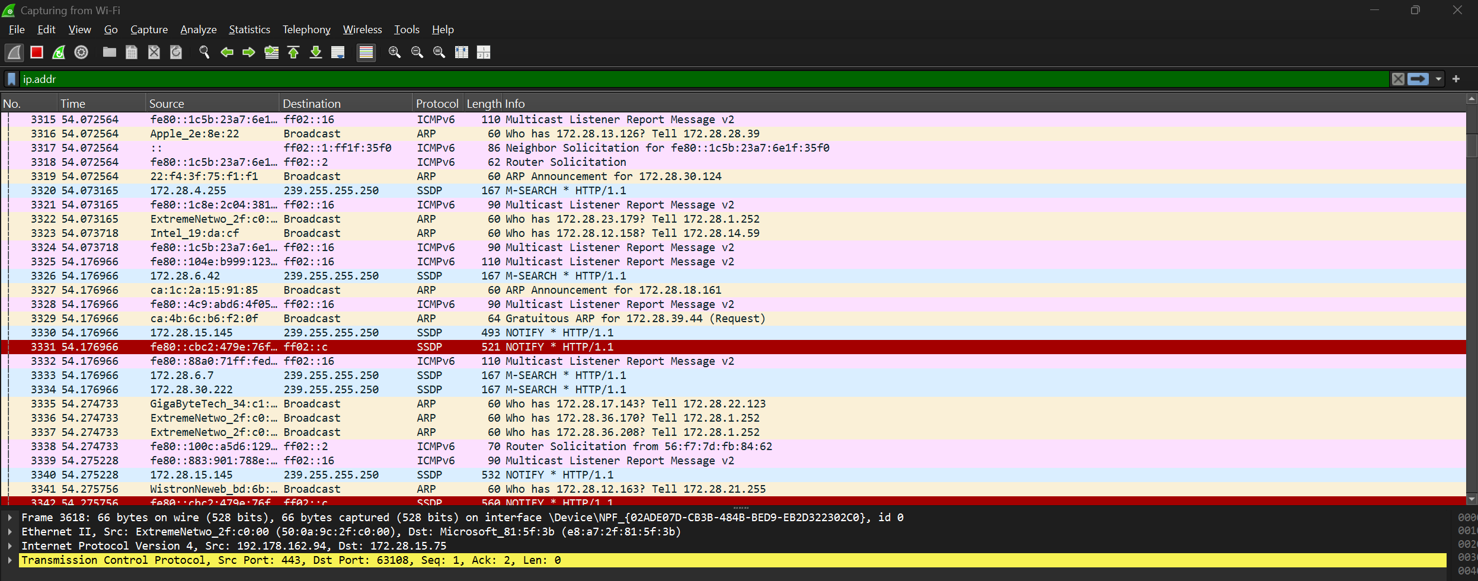
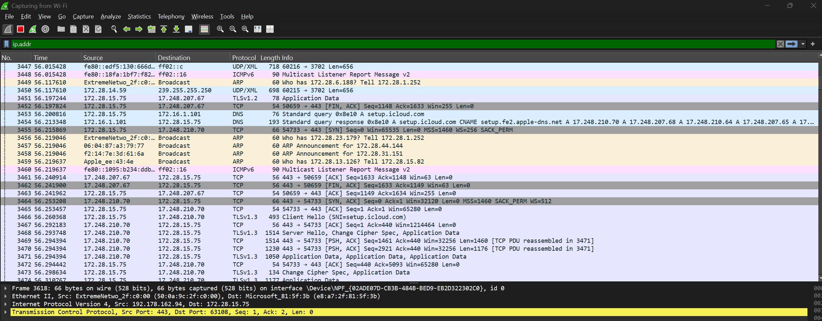
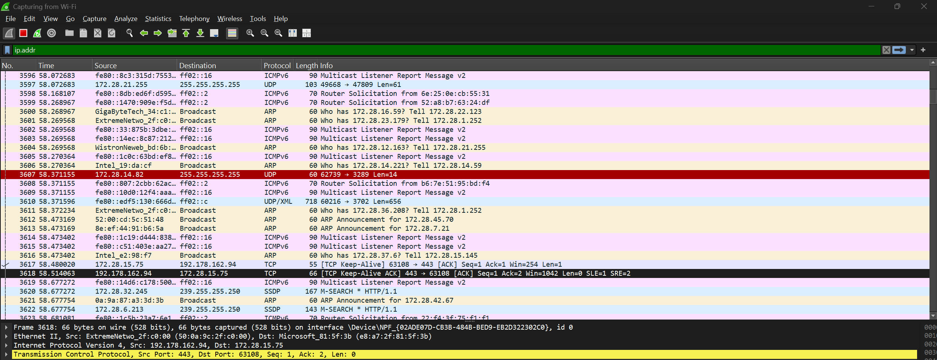
These are three captures from my overall capture. I will use the snipping tool to highlight the following requested packets from one of the three captures above.

- Show one private and one public IP address.

The source that in which the packet was sent from has a private IP address as it fits in the range from 172.16.0.0 to 172.31.255.255.

The source above is a public IP address as it is sending a packet to a private IP address fitting in the required range.

- Show a TCP and a UDP packet. What is a TCP and UDP packet?
Above is a TCP packet.
Above is a UDP packet.

According to Tech Differences, both protocols TCP and UDP are transport layer protocols. In which cases, both are used to transmit data over networks.
The TCP is a connection-oriented protocol, which connects before it transmits the data.
However, the UDP protocol is a connectionless oriented protocol, which does not establish a connection before transmitting data (Tech differences)

- Show a TLS packet. What is a TLS packet?

A TLS packet is referred to a transport layer security packet. The TLS protocol was created for the privacy and data security of communications over networks and the internet. The TLS encrypts data from the web and servers. For example, this protects data from a web browser when it loads a website.

- How many total packets are in your capture?
There is a total of 64,792 packets during my capture, as I let it run for 943 seconds.

- Do a ping of 1.1.1.1. Show this activity in Wireshark. What protocol does ping use?
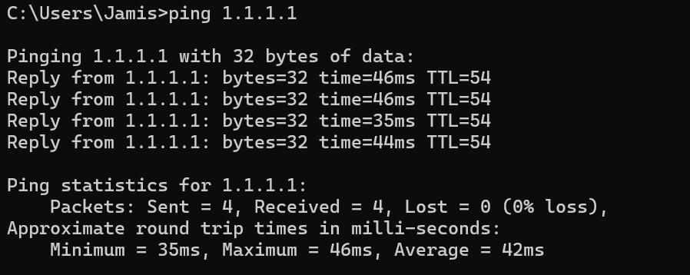
Pinging 1.1.1.1
Wireshark packet of a source 172.28.15.75 sending a request to 1.1.1.1. This uses an ICMP protocol which is the internet control message protocol used to send error messages.

References
- https://techdifferences.com/difference-between-tcp-and-udp.html
- What is Transport Layer Security (TLS)? | Cloudflare

